



Web Technology (4NCC01)

Personal Website

Student Id : np03cs4a220205

Student Name : Bhupen Tuladhar

Group : L4CG9

Tutor : Mrs. Yojana Ghimire

Submitted on : 2023/02/06

Reflective Writing

Header

In my website, the header page contains a logo and navigation bar with links to Home, About, Education, Hobbies, Skills and Contact pages. I have used CSS for colors to maintain consistency throughout the website. I have fixed the header at the top of the page so that the navigation links can be used throughout the website. I have also designed the header to be responsive with the help of media query so that the website can be viewed on lower screens.



Home

In the Home page, I have introduced myself. The Home page includes my image, a heading and a subheading. I have made the image adapt to different screen sizes and maintain the aspect ratio with CSS. I have positioned the heading and subheading at the center of the page using the flexbox layout for easy alignment. I have also designed the Home page to be responsive by using media query, reducing the font size and image height for smaller screens to maintain the appearance.

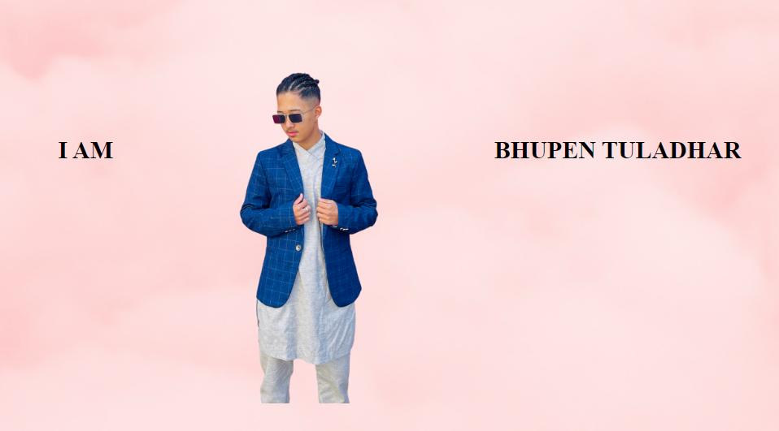

About

In the About page, I have showcased on who I am as a student and individual. I have included my image as well as a heading and a subheading. To ensure that the image displays correctly on different screen sizes, I have used CSS to make the image adaptable and maintain its aspect ratio. I have also used flexbox layout to position the heading and subheading in the center of the page for alignment and symmetry. To make the home page responsive, I used media query to maintain the appearance for smaller screens. The design includes elements such as a background image and a button to download my CV. The code also includes hover effects to change the button color when a user's mouse is over it.

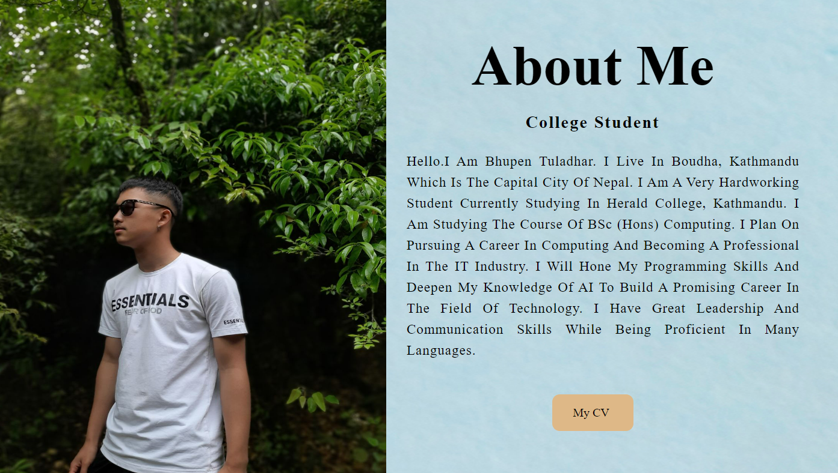

Education

In the Education section page, I have provided information about my education history. I have created a table to display the name of the institutions I have attended, the years I attended, and the level of education. The table is designed to be easily readable and organized with borders, a caption, and font-size adjustments. The section also has a header that reads "My Education." I have added a background image to the section to make it visually appealing. Additionally, the section is designed to be responsive and adjust to different screen sizes.

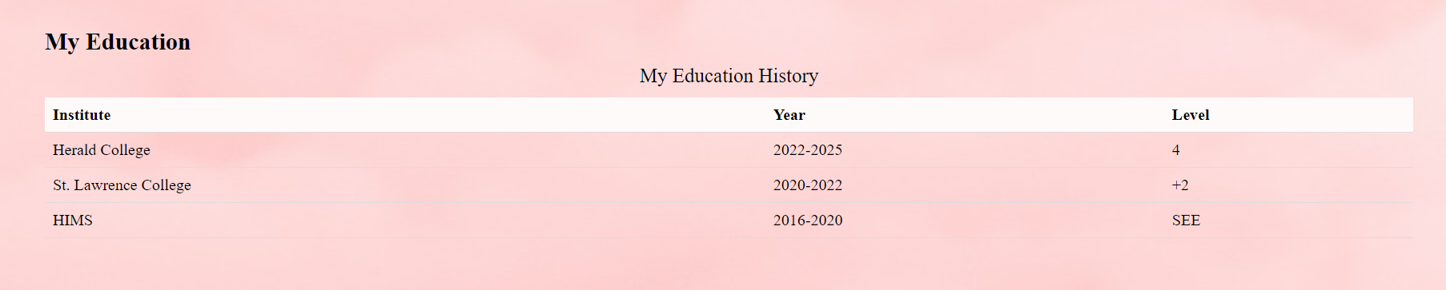

Hobby

In the Hobby section page, I have listed out my various hobbies. Each hobby is displayed in a separate block with a margin, padding, and a background color. The section has a header reading "My Hobbies". To give the section a visually appealing look, I have added a background image. The section is designed to be responsive, adjusting to different screen sizes.

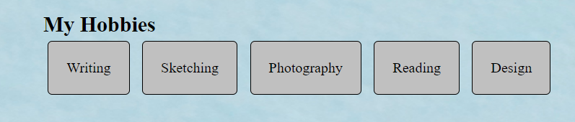

Skills

In the Skills section page, I have listed out my various skills. Each skill is displayed in a separate block with a margin, padding, and a background color. The section has a header reading "My Skills ". To give the section a visually appealing look, I have added a background image. The section is designed to be responsive, adjusting to different screen sizes.

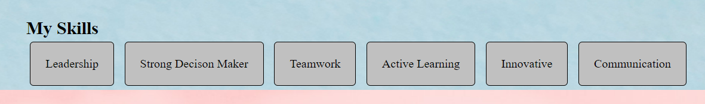

Contact

In the Contact section page, I have provided a form for users to input their name, email, and message. The form has labels for each input, and the input fields are set to be required. The section also has a header that reads "Contact Me." I have added a background image to the section to make it visually appealing. Additionally, the section contains social links to my Instagram, LinkedIn, Facebook, and GitHub profiles, which are displayed using font icons. The social links are centered and have a margin between them. The section is also designed to be responsive, adjusting to different screen sizes.

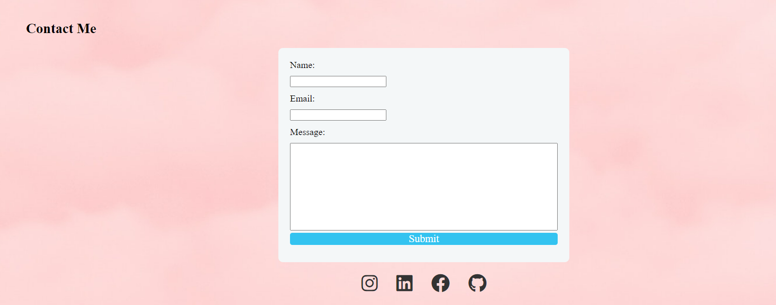

Footer

In the footer of the webpage, I have written a statement that says "Copyright 2023 All rights reserved." This text serves as a notice to the website visitors that the content of the site is protected under copyright law and cannot be used without permission.

